**臺北市獸醫師公會2024年第12次繼續教育學術研討會通知**

1. 主辦單位：臺北市獸醫師公會
2. 協辦單位：愛德士生物科技股份有限公司
3. 時間：113年10月27日(星期日)19時30分至21時30分**(19時準時報到)**
4. 地點：台北晶華酒店4樓貴賓廳(台北市中山區中山北路2段39巷3號4樓)
5. 課程表

|  |  |  |
| --- | --- | --- |
| **時間** | **Agenda** | **講師** |
| 18:30-19:30 | **晚餐(Buffet)** | |
| 19:00-19:30 | **報到Check-in（攜身分證刷條碼簽到）** | |
| 19:30-20:15 | Piecing the puzzle with Catalyst Pancreatic Lipase test - Diagnosis and Management of Canine Acute Pancreatitis 1  解析犬急性胰臟炎的診斷拼圖與疾病管理 1 | **Graham Ronald SWINNEY**  **譯：張瓈文 獸醫師** |
| 20:15-21:00 | Piecing the puzzle with Catalyst Pancreatic Lipase test - Diagnosis and Management of Canine Acute Pancreatitis 2  解析犬急性胰臟炎的診斷拼圖與疾病管理 2 | **Graham Ronald SWINNEY**  **譯：張瓈文 獸醫師** |
| 21:00-21:30 | Q & A | **Graham Ronald SWINNEY**  **譯：張瓈文 獸醫師** |
| 21:30~ | **結束後刷身分證條碼簽退** | |

1. 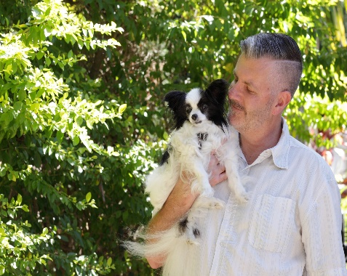講師介紹：

**Graham Ronald SWINNEY**

學歷：Diploma of Veterinary Clinical Sciences, Massey University

現職：IDEXX Laboratories, Australia/New Zealand Internal Medicine Consultant/Medical Affairs Veterinarian

專長：小動物內科、獸醫臨床教學

**獸醫教學資歷**

# SEMINARS AND CONTINUING EDUCATION PRESENTATIONS

New Zealand Veterinary Association Conference 1989

Society of International Veterinary Symposia 1989

New Zealand Continuing Education Committee Conference on Cardiology 1990

Australasian Veterinary Schools Group Meeting 1991

New Zealand Continuing Education Committee Feline Medicine Conference - Case Studies 1991

New Zealand Companion Animal Society Small Animal Medicine Conference - Case Studies 1993

University of Sydney Postgraduate Foundation Conference on Basics in Internal Medicine 1994

Australian College Of Veterinary Scientists Anniversary Conference1995

Australian Veterinary Association Annual Conference Young Speakers Section 1995

Australian Association of Veterinary Diagnostic Imaging Conference 1996, 1998, 1999

University of Sydney PGF/CVE Time Out (Sydney) 1996, 1997, 1998, 1999, 2006, 2008

University of Zurich Veterinary Postgraduate Students Organisation 1997

Australasian Winter Veterinary Conference 1998

WSVMA Yakima Branch 2002

Australian College Of Veterinary Scientists Science Week 2002

Pilchuk Emergency Group Seminar 2002

AAFP Student Chapter Symposium 2003

WSU Annual Spring Conference 2004, 2005

Australian Small Animal Veterinary Association Annual Conference 2005, 2009, 2010-13, 2015, 2016

Post Graduate Foundation on Continuing Education Sun, Surf and Sixteen Speakers 2005

Newcastle Branch of the AVA 2005

Veterinary Specialist Centre Seminar Series 2005-2009

Post Graduate Foundation Soft Tissue Surgery 2007

Post Graduate Foundation Weekend Course Brisbane 2008

Post Graduate Foundation ICU in Sydney

Centre for Veterinary Education Pharmacology 2008

Nepean AVA Branch Meeting 2009

AVA WA Division Annual Conference 2010, 2018

ASAVA R&R Conference Kingscliff 2010

AVA NSW Division Regional Conference 2011, 2013

AVA NT Division Annual Conference 2015

AVA Tasmanian Division Annual Conference 2012, 2013, 2014, 2015, 2106, 2017, 2018, 2019

FASAVA Conference 2017

VNCA Annual Conference 2017, 2018

Vets on Tour Wanaka 2019

七、報名費用：

（一）臺北巿獸醫師公會會員及非會員均免費報名。

（二）限額140位額滿即截止受理報名（未加入各縣市獸醫師公會之獸醫師及獸醫學系學生請勿報名）。

八、報名方式：

即日起額滿為止，請自行上google表單填寫

<https://forms.gle/VYmNzehpfmYPMTYX7> ，會員請先將113年會費繳畢再行報名，**請儘早報名。**

**九、交通資訊：**

**(一)高鐵  
搭乘高鐵至台北站，並轉搭捷運至淡水線中山站3號出口，步行約6分鐘即可抵達。**

**(二)開車資訊  
行經中山高速公路於重慶北路交流道出口下交流道-至民族東路左轉-直走至林森北路右轉即可抵達。**

**(三)捷運資訊  
搭乘捷運淡水線(紅線)中山站3號出口，步行約6分鐘即可抵達。**

**(四)公車資訊  
公車：218、220、221、227、247、260、261、287、310、40、636、659，於國賓飯店站下車，步行約3分鐘即可抵達。**

**(五)停車  
飯店備有代客停車服務，同時於飯店地下4、5樓為貴賓專用停車場，方便來賓們使用。**

**此場學分積分請逕上獸醫師執業繼續教育積分管理系統課程總覽查詢**

**※請注意：不論用任何方式報名進來，報名進來的會員須為公會有效會員，若被公會停權，即使有參加及簽到簽退，公會不會接受報名及申請其繼續教育學分。**